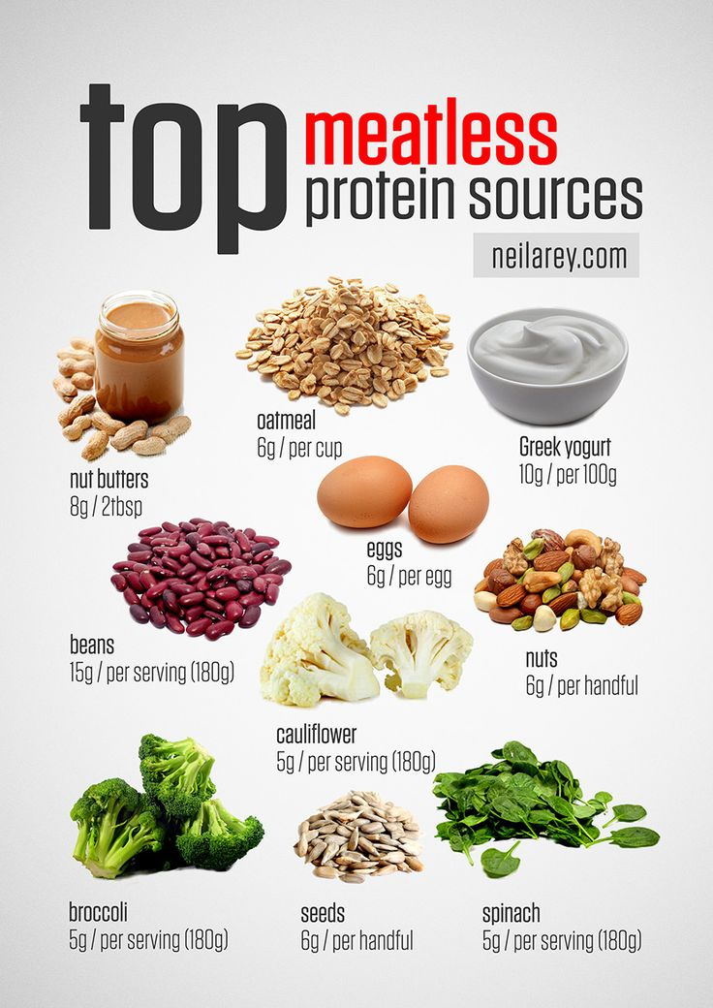
Whether you're fueling up before hitting the gym or taking a midday snack break to avoid the 3 p.m. lull, high-protein snacks are the tastiest way to keep on going. These snacks that pack in plenty of protein along with other nutrients are the perfect way to fill up, and give us longer-lasting energy than carb-heavy options.
And if you think you're limited to boring hard-boiled eggs, think again. These 27 delicious, healthy, and easy options have even more protein than an egg (one large contains about 6 grams).

1. Nut Butter Boat: a few celery sticks with a serving of any nut butter (like almond, cashew, walnut) topped with a few whole almonds or raisins.

2. Jerky: low-sodium, natural, or lightly-flavored

3. Mixed Nuts or Trail Mix: Try a mixed bunch for variety and a combo with dried fruit for some added sweetness

4. Deli Rollups: 2 slices deli turkey rolled up with 1 slice cheese and 1 slice tomato (almost double the protein of a hardboiled egg)
5. Pumpkin Seeds: healthy little snack full of fiber and immunity-protecting zinc once they’re washed, dried, and nicely roasted. 2/3 cup pumpkin seeds, rinsed and coated with 1 tsp curry powder and a pinch of salt, roasted at 300 degrees for 20 minutes: 8 grams protein

6. Chunky Monkey Shake: a high-protein beverage, including this banana-y pick-me-up, bulked up with chocolate milk and peanut butter, which provides both healthy fat and cardiovascular benefits in addition to protein.
1 medium banana, 1 tablespoon of peanut butter, and 1 cup of low fat chocolate milk blended with 1 cup of ice: 15 grams protein

7. Shake it Up: When it comes to protein shakes, the combinations are endless! Pour yours into a portable tumbler for a sippable snack on the go (1 scoop vanilla whey protein powder, 1 cup orange juice, and 1 cup ice blended until smooth).

8. Mini Bean-and-Cheese Quesadilla: It might take an extra minute to prep, but combining these two high-protein treats is totally worth it, especially when the result boasts both fiber and calcium too. Cook it in a dry nonstick pan until the cheese is melted and tortilla is lightly browned, then wrap it in foil and stick in a plastic baggie for easy transport. (1/2 cup black beans, 1 tablespoon salsa, and 1 slice cheddar cheese in a small whole wheat tortilla: 17.9 grams protein)
9. One Kind Plus Bar: KIND Plus bars -all-nut base. When you’re really in a pinch but are reaching “hangry” status, keep one of these stashed in your bag as a quick, nutritious snack.
(1 Almond Walnut Macadamia with Peanuts KIND Plus Bar: 10 grams protein

10. Edamame Poppers: The only thing more fun than how much protein you can get from a serving of edamame is getting to eat these little beans out of their bright green pods. Buy them fresh and steam, or use the pre-cooked frozen variety and briefly microwave to defrost before chowing down. (1 cup edamame pods sprinkled with sea salt: 15 grams protein)

11. Hummus Dippers: Put a your favorite hummus in the bottom of the container, stick a handful of vegetable sticks (carrots, celery, and snow peas are a great mix) vertically in the hummus, screw on the top, and throw in a purse or gym bag for an easy, on-the-go, super-healthy snack. (1/3 cup hummus with 1/2 cup mixed vegetable sticks: 6.7 grams protein)

12. Greek Yogurt and Granola: the Greek yogurt snack provides plenty of calcium and probiotics to fight inflammation. (1 single-serving container yogurt with 2 tbsp granola: 16 grams protein)

13. Portable Cheese Platter: Fill a Tupperware box) with a cheese stick along with some whole-grain crackers for crunchy carb action, and a few almonds for an all-around protein, healthy fat, and fiber upgrade. (1 stick 2-percent string cheese with 3 whole-wheat crackers and 10 almonds: 9.6 grams protein)

14. Mini PB&J: Use all-natural peanut (or almond!) butter and a fruit-juice sweetened jelly to avoid trans fats and extra sugars.(1 slice whole-wheat bread with 1 tbsp natural peanut butter and 1 tsp all-fruit jelly: 9 grams protein)
15. Perfect Parfait: In a transportable container, alternate layers of nonfat Greek yogurt with a handful of fruit (either fresh or frozen works great!). Then top with a drizzle of honey and a sprinkling of toasted oats to add crunch to this protein- and probiotic-packed treat.
(1/2 cup nonfat Greek yogurt with 2 tablespoons oats and 2 tablespoons berries: 12.9 grams’ protein)

16. Gobble, Gobble: (One piece whole-grain bread, sliced lengthwise, topped with 2 slices roasted turkey, 1 slice Swiss cheese, 1 lettuce leaf, 1 slice tomato, 1 teaspoon mustard, and 1 teaspoon dried cranberries: 20.4 grams protein)

17. Chocolate Milk: Chocolate milk is actually a great source of high-quality protein (especially post-workout). Try keeping a single-serving, shelf-stable box in your gym bag or backpack for snack attack emergencies—just try to find one that’s also low in sugar! (1 cup one-percent, reduced sugar chocolate milk: 9 grams protein)

18. Tuna and Crackers: Along with protein, canned tuna adds some vitamin D and omega-3 fatty acids to your mid-afternoon munchies. Scooped up with a few whole wheat crackers, it’s a mini-meal that’s both simple and satisfying. (1 single serving (3-ounce) pack of wild albacore tuna salad (try the Starkist brand) plus 11 Wheat Thin crackers: 12 grams protein)
19. Basic Burrito: When the mid-afternoon slump calls for something spicy to wake you up, try this bite-sized flavor fiesta. The bulk of the protein comes from the black beans and cheddar, while a spoonful of salsa adds a small but powerful dose of cancer-fighting lycopene. If you want to make it vegan but equally protein-rich, just replace the cheese with extra beans.
(1 small whole wheat tortilla, 2 tbsp mashed black beans, 2 tbsp shredded cheddar, 1 tbsp salsa: 8.4 grams protein)

20. Toasted Quinoa: Enjoy the gluten-free superfood: lightly sweetened, and toasted to crunchy perfection. Pack it in a container on top of yogurt, or like we tend to do with our favorite granola, eat it by the handful! (1/3 cup quinoa mixed with ½ tbsp ground flax, 1 tbsp shredded coconut, and 1 tbsp maple syrup, toasted at 425 degrees for 10 minutes: 9.4 grams protein)
21. Protein Bites: No baking required, only four ingredients, portable, and tastes like dessert? This is our kind of quick-fix treat! Nut butter acts as the binder as well as the source of most of the protein in this recipe, while oats and dark chocolate chips give it its cookie-like quality while adding both fiber and antioxidants.
(1 1/2 tbsp nut butter, 3 tbsp oats, 1/2 tbsp honey, 1/2 tbsp dark chocolate chips, rolled into balls: 8 grams protein)

22. Grape-and-Cheese Sticks: Dice a half-inch thick slice of cheddar cheese into squares (you should end up with about 6 small pieces), and alternate the cubes with grapes onto toothpicks. The sweet and savory contrast of the cheese and fruit is super sophisticated (and delicious), and a little bit goes a long way to fit your protein needs.
(1 ounce cheddar cheese with 6 grapes: 7.1 grams protein)

23. “Cheesy” Popcorn:When it’s not doused in butter and artificial flavorings, popcorn can be a super healthy snack, thanks to being a fiber-rich, satiating whole grain. Ratchet up its protein content by dusting the kernels with nutritional yeast, the vegan, B vitamin-packed answer to parmesan cheese.
(3 cups air-popped popcorn coated with 2 tbsp nutritional yeast and a sprinkle of salt: 8.9 grams protein)

24. “Cheesy” Kale Chips: The ultimate in salty cravings, potato chips are one of the easiest snacks to overdo it on (seriously, who eats just one serving at a time?!). Next time you need a big pile of something crunchy on the go, swap out the store-bought spuds for a baked bunch of homemade kale chips instead. While just as crisp as regular chips, this two-cup serving comes with the added benefits of giving you over 40 percent of your daily value of vitamin A and C, plus a hefty dose of protein from the nutritional yeast topping.
(2 cups kale leaves coated with 1 tbsp olive oil and 2 tbsp nutritional yeast, baked at 325 degrees for 15 minutes: 9 grams protein)

25. Homemade Chia Pod: Soak the chia seeds in non-dairy milk right in a portable container so that all you have to do is grab and go for a snack that’ll give you more than 30 percent of your daily value for calcium, iron, and magnesium.(1/4 cup chia seeds, 1 cup almond milk, 1/2 tbsp honey: 7 grams protein)

26. Roasted Chickpeas: 3/4 cup chickpeas roasted for 20 to 30 minutes with 1 tablespoon each olive oil, salt, and cayenne pepper: 9 grams protein.
Plan weekly trays full of protein snacks and fill full eat less, eat healthy!
