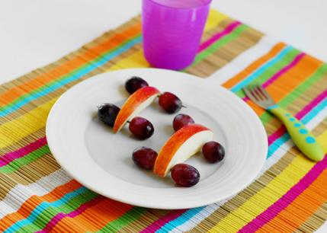

Cut apples into 1/2-inch slices. Insert toothpicks horizontally into both ends of the apple slice. Slide grapes onto the toothpicks to make wheels. Who knew [healthy snacks](https://www.parenting.com/tags/healthy-food) could be so much fun?

**Apple and Grape Cars**

Using kitchen scissors, cut the bottom of the string cheese in half, approximately halfway up the stick of cheese. Keep halving the string cheese pieces with scissors until there are eight tentacles. To make eyes, cut a raisin in half and stick it to the string cheese with [peanut butter](https://www.parenting.com/article/crunchy-peanut-butter-sandwich-picky-eaters).

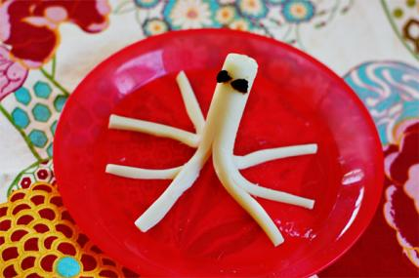

**String Cheese Octopus**

Slice two [strawberries](https://www.parenting.com/blogs/kid-friendly-recipes/holly-v-kapherr/strawberry-recipes) into 1/4-inch slivers. Arrange the slices into the form of flower petals. Fill the middle with blueberries and use a stalk of celery for the stem and leaves.

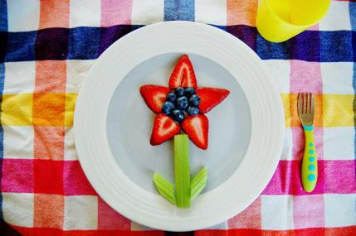

**Strawberry Flower**

Cut four slices of [cucumbers](https://www.parenting.com/article/ham-and-veggie-pinwheels) for wheels. Take a piece of string cheese and horizontally insert two toothpicks into each end. Slide the cucumber slices on the toothpicks for the wheels. Make a small hole in the top of the string cheese at one end and insert a pretzel stick into it. Use cream cheese to attach a second pretzel stick horizontally for the handlebars.

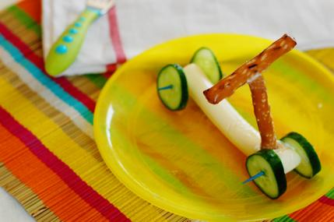

**Veggie and Pretzel Scooter**

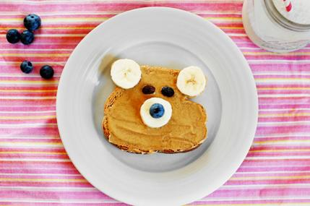

Toast one piece of whole wheat bread. Spread peanut butter on the entire surface of the [toast](https://www.parenting.com/article/cinnamon-toast-picky-eaters). Place two banana slices in the top corners of the toast as the ears and one slice in the middle for the snout. Place a blueberry on the snout for the nose, and finish it off with raisins for eyes. Healthy snacks can be yummy and cute!

**Teddy Bear Toast**

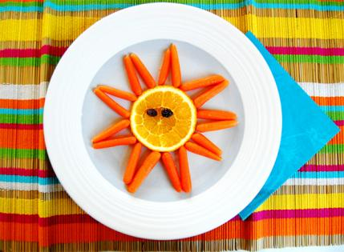

Thinly cut one large [orange](https://www.parenting.com/blogs/kid-friendly-recipes/orange-recipes) into circular slices. Place one slice in the center of a plate. Arrange baby carrot sticks around it into triangular-shaped rays, and give it a happy face by placing two raisins on the orange as eyes.

**Orange and Carrot Sun**

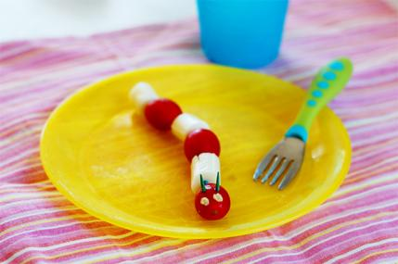

Arrange grape tomatoes and [mozzarella](https://www.parenting.com/article/mozzarella-tomato-salad-for-kids) balls into a wiggly caterpillar body shape. Using a toothpick, dab two small dollops of hummus on the front tomato for the eyes and then stick two halves of one toothpick in the top of the [tomato](https://www.parenting.com/article/baked-eggplant-mozzarella-and-tomato-casserole) head for the antennae.

**Tomato and Mozzarella Caterpillar**